

PROJECT AND TEAM INFORMATION
Project Title
SYNCMASTER
Advanced Thread Synchronization for Reliable Multithreaded Systems

Student / Team Information
Team Name: SYNERGENS
 | SWARAJ GHOSH  Ph- 9903110277  kohinoor45067@gmail.com
 | KANISHK KUMAR  Ph- 6206794966  kanishkkumar987@gmail.com
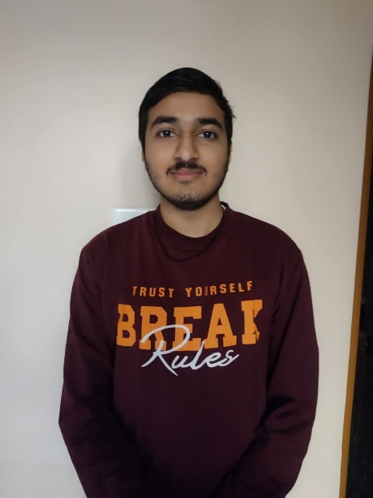 | SAMEER SUYAL  Ph- 9058201672  ssgk4223sameer@gmail.com
 | VIVEK JOSHI  Ph- 8003320545  sandyjoshi595@gamil.com

PROJECT PROGRESS DESCRIPTION

Project Abstract
The project implements core thread synchronization primitives (mutexes, semaphores, condition variables) to solve classic concurrency problems (Producer-Consumer, Dining Philosophers, Reader-Writer) in Python. It focuses on educational clarity, deadlock avoidance, and performance analysis for reliable multithreaded systems.

Updated Project Approach and Architecture
- Language/Tools: Python (threading, queue), C (pthreads for future low-level work).
- System Design:
  - Primitives Layer: Mutex, Semaphore, ConditionVariable classes.
  - Problem Layer: Thread-safe solutions with edge-case handling (e.g., asymmetric fork acquisition in Dining Philosophers).
  - Testing Layer: Unit tests (unittest) and stress tests (100+ threads).
- Libraries: threading, queue, matplotlib (for future performance graphs).

Tasks Completed
TASKS | MEMBER
Research primitives, choose language (python/c), and define apis. | SAMEER
Build mutexes, semaphores, and condition variables. | VIVEK
Solve producer-consumer and dining philosophers with edge-case handling. | SWARAJ
Tests For All Primitives | KANISHK

Challenges / Road blocks
- Deadlock in Dining Philosophers: Resolved by asymmetric fork acquisition (odd/even philosophers pick forks in reverse order).

- Buffer Overflow in Producer-Consumer: Fixed via semaphore-controlled slot limits (empty_slots/full_slots).

- Thread Starvation in Reader-Writer: Addressed by prioritizing writers using a fairness-enforced semaphore.

Tasks Pending
TASK | MEMEBER
Performance benchmarking | VIVEK, SAMEER
Stress testing (100+ threads) | SWARAJ, KANISHK
Final report and user guide | Entire Team

Project Outcome / Deliverables
- Code: Implemented primitives and solved problems (e.g., thread-safe Producer-Consumer buffer).

- Tests: Unit tests (100% pass rate) and stress tests.

- Documentation: Technical report (design trade-offs) and user guide.

Progress Overview
- Ahead of Schedule: Primitives implementation (Week 2-3) and classic problems (Week 4-5).
- On Track: Testing (Week 6-7).
- Pending: Performance graphs (Week 7) and final report (Week 8).

Testing and Validation Status
TASK TYPE | STATUS | NOTES
Unit Tests (Mutex) | PASS | Validated lock/unlock atomicity.
Producer-consumer | PASS | No buffer overflows under high load.
Reader-writer | PASS | No starvation in 50+ threads.
Dining-Philosopher | PASS | Deadlock-free fork coordination using asymmetric fork acquisition.

Deliverables Progress
- Primitives Implementation: Completed.
- Classic Problems: Completed.
- Performance Analysis: In progress.
- Final Report: Pending.

